Project Design Phase
Solution Architecture Document
Date | 27 September 2026
Team ID | 6ab1d5c192b876d9664095f0
Project Name | Streamlining IT Procurement: Automating Standard Laptop Orders with Flow Designer
Maximum Marks | 4 Marks

Solution Architecture Overview:
Solution architecture is a complex process – with many sub-processes – that bridges the gap between business problems and technology solutions. Its goals are to:
• Find the best tech solution to solve existing business problems.
• Describe the structure, characteristics, behavior, and other aspects of the software to project stakeholders.
• Define features, development phases, and solution requirements.
• Provide specifications according to which the solution is defined, managed, and delivered.
Solution Architecture Diagram:
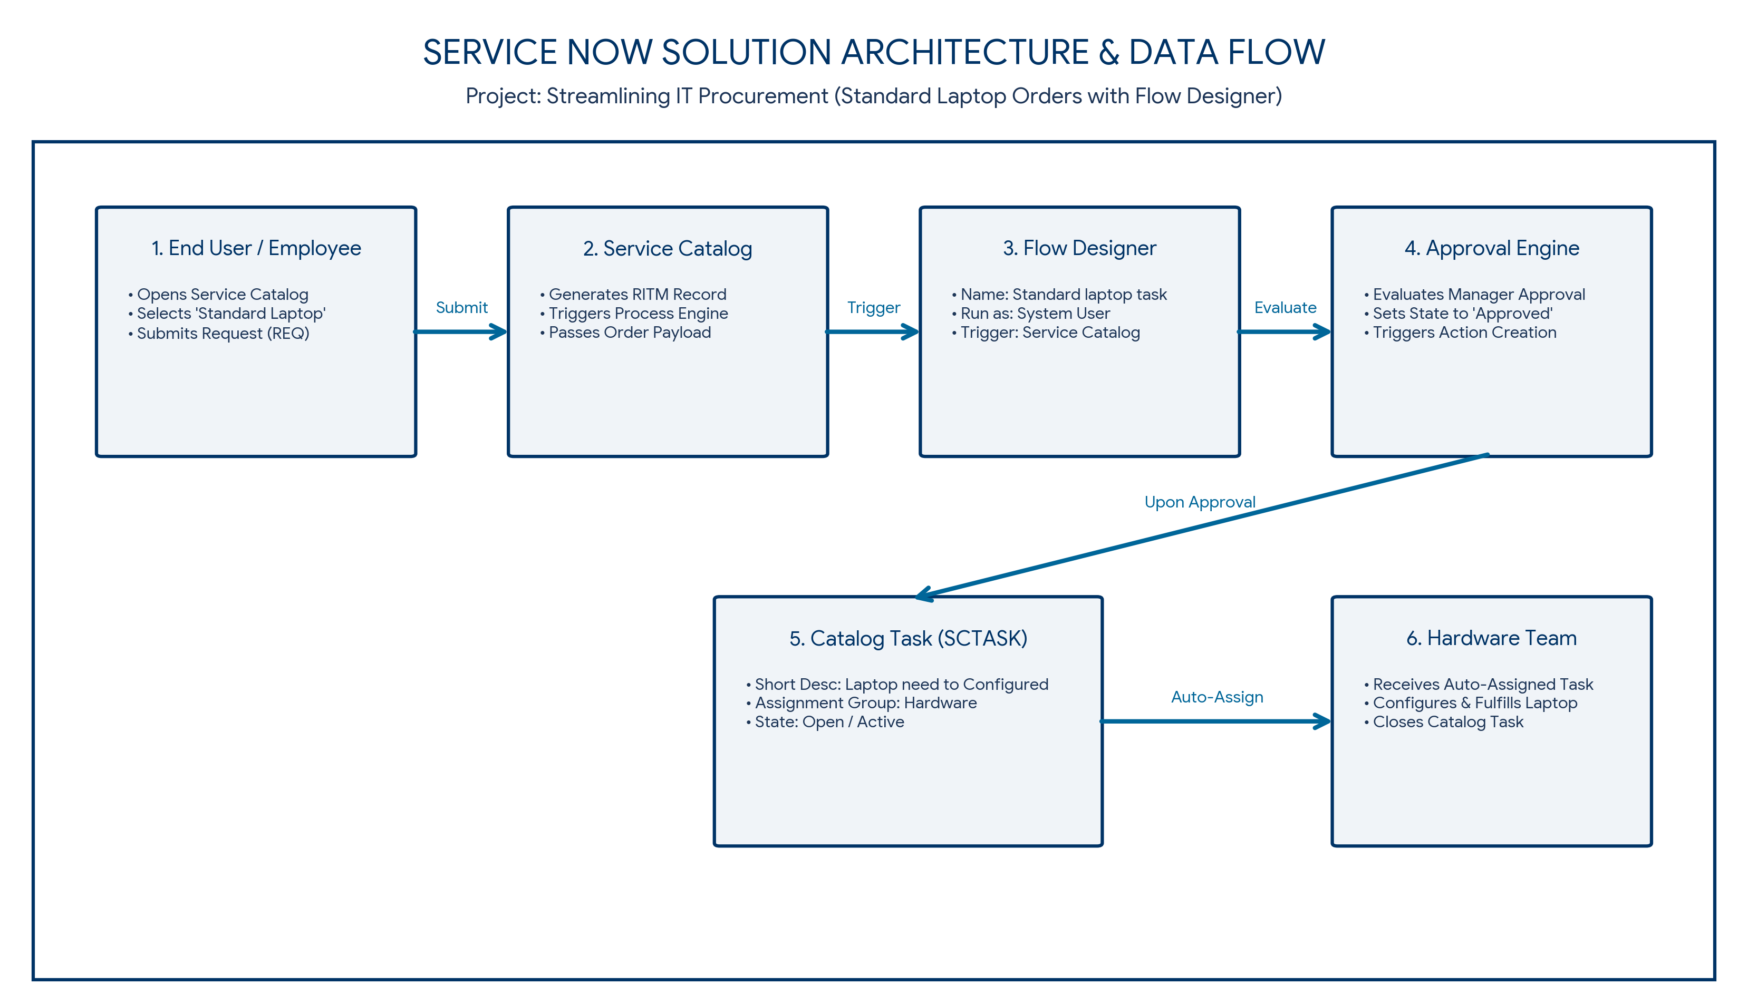
Figure 1: Architecture and data flow of the ServiceNow IT Procurement automation application
Architecture Components & Data Flow Steps:
S.No. | Architecture Component | Description & Technical Integration Details
1 | End User / Employee Interface | The requestor selects and orders the 'Standard Laptop' catalog item from the ServiceNow Service Catalog portal, entering specific configuration requirements.
2 | Service Catalog & Process Engine | The Service Catalog receives the submission, creates a Request (REQ) & Requested Item (RITM) record, and triggers the configured Process Engine Flow.
3 | Flow Designer Core | Executes the 'Standard laptop task' flow configured in Global scope under 'System User' context, triggered directly by Service Catalog events.
4 | Approval Workflow Engine | Processes approval routing rules. Once the RITM state changes to 'Approved', Flow Designer automatically proceeds to create downstream fulfillment tasks.
5 | Catalog Task (SCTASK) Generator | Flow Designer automatically instantiates a Catalog Task record linked to the RITM, auto-populating short description, description, and setting approval status.
6 | Hardware Team Auto-Assignment | Dynamically sets the 'Assignment Group' field to 'Hardware'. The task is immediately dispatched to the Hardware fulfillment queue for laptop configuration and dispatch.

